**My work for Day:02**

**MARKETPLACE TECHNICAL FOUNDATION – COMFORTY**

**1. Technical Work:**

* ***Frontend Requirements***
* ***User-Friendly***: Easy navigation and intuitive product browsing.
* ***Responsive Design***: Mobile, tablet, and desktop support.
* ***Essential Pages***: Home, Product Listing, Product Details, Cart, Contact, About, FAQS, Checkout, Order Confirmation.
* ***Sanity CMS as Backend***
* ***Data Management****:* Manage products, customers, and orders.
* ***Schema Design****:* Create schemas for Products, Orders, and Customers.
* ***API Integration****:* Use Sanity APIs for frontend data fetching.
* ***Third-Party APIs***
* ***Shipment Tracking***: Fetch delivery updates (e.g. ShipEngine, More).
* ***Payment Gateway****:* Secure payments (e.g., Snipcart, more).
* ***Notifications****:* Send order confirmations via email or SMS.

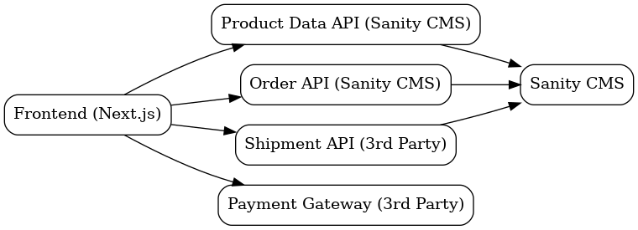**system arch:**

**3. API Requirements:**

**Product**

* **Endpoint Name**: /products
* **Method**: GET
* **Description**: Fetch all available products from Sanity.
* **Response**: Product details (ID, name, price, description, stock, image).

**Order**

* **Endpoint Name**: /orders
* **Method**: POST
* **Description**: Create a new order in Sanity.
* **Payload**: Customer info, product details, payment status.

**Customer**

* **Endpoint Name**: /customers
* **Method:** POST
* **Description:** Register a new customer in the system.
* **Payload:** Customer info (name, email, address).

**Delivery Zone**

* **Endpoint Name:** /delivery-zones
* **Method:** GET (Third Party. e.g. ShipEngine, etc.)
* **Description:** Fetch available delivery zones.
* **Response:** Delivery zone details (ID, name, delivery cost).

**Payment**

**Endpoint Name:** /payment

* **Method:** POST (Third Party. e.g. Snipcart, etc.)
* **Description:** Process a payment for an order.
* **Payload:** Payment info (order ID, amount, payment method).
* **Response:** Payment status (successful or failed).

**4. Documentation:**

* + **System Architecture Overview:**

***Frontend (Next.js)***

* **Role:** Displays the user interface, handles interactions, and provides server-side rendering for fast load times and SEO.

***Backend (Sanity CMS)***

* **Role:** Manages and stores dynamic content (products, orders, customer, delivery zone, payment) and provides APIs for the frontend to fetch data.

***Third-Party APIs***

* **Role:** Integrates external services for payment processing (Snipcart, more), shipping (shipengine, etc.), and other functionalities.
* ***Database (Managed by Sanity)***
* **Role:** Stores structured data (products, users, orders) for easy access and management through Sanity’s APIs.
  + **Key Workflows:**

**Add to Cart**

User adds products to cart (frontend updates state).

**Checkout**

User enters shipping info, and shipping rates are fetched via ShipEngine.

**Payment**

User makes payment via Snipcart API.

**Order Confirmation & Delivery**

Order is confirmed, and shipping label is created via ShipEngine; user gets tracking details.

* + **Workflow Diagram:**

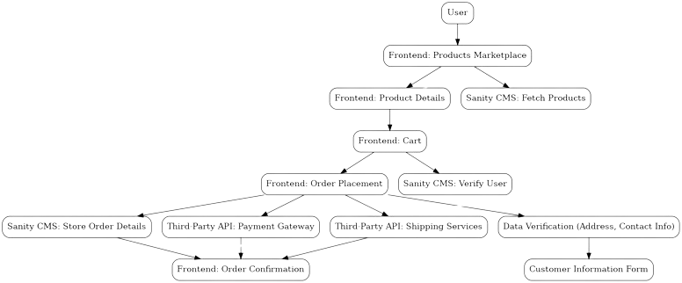

* + **Data Schema Design:**

**Entities and Relationships**

**Product**

**Fields:**

ID (number)

Name (string)

Price (number)

Description (text)

Image (image)

Stock (number)

**Order**

**Fields:**

ID

Customer ID

Quantity

Total

Order Status

**Customer**

**Fields:**

Customer ID

Name

Email

Phone

Shipping Address

**Delivery Zone**

**Fields:**

Zone ID

Region

Delivery Time, Charges

Available Options

**Payment**

**Fields:**

Payment ID

Order ID

Amount

Payment Method

Status

* + **Technical Roadmap:**

**Phase 1: Planning**

Define scope, features, wireframes.

Deliverables: Scope, UI mockups.

**Phase 2: Frontend**

Set up Next.js, cart, CMS integration.

Deliverables: Product catalog, cart.

**Phase 3: Backend**

Set up Sanity CMS, API routes, third-party integrations.

Deliverables: Backend, payment tracking.

**Phase 4: Payment & Shipping**

Integrate Snipcart, ShipEngine.

Deliverables: Payment, shipping setup.

**Phase 5: Testing**

Test and optimize.

Deliverables: Bug-free platform.

**Phase 6: Deployment**

Deploy site, set up monitoring.

Deliverables: Live site.

**Phase 7: Post-Launch**

Monitor and update.

Deliverables: Regular updates.

**Name : BEENISH RAJPUT**

**Roll Number : 00490738**

**Shift : Sunday 9 to 12 pm**